User Guide

Virtual Letter of Life (VLOL) Application

Version 2.1

Michael Shaw

Michael Marcucci

Kimberly Van Allen

Andrew Coleman

Heather Barnes

Panhavorn Hok

SWEN 670 Software Engineering Project

University of Maryland Global Campus

Date: 10/17/2021

**REVISION HISTORY**

|  |  |  |
| --- | --- | --- |
| **Date** | **Version** | **Description** |
| 08/04/2020 | 1.0 | Initial User Guide Document Release  Reviewed by EMSPlus internal team |
| 10/31/2020 | 2.0 | Reviewed and approved by VLOL Team |
| 11/02/2020 | 2.1 | Updated with feedback from Roy Gordon |

Table of Contents

1. Introduction 7

1.1 Overview 7

1.2 Intended Audience 7

1.3 Additional Documentation 8

1.4 Acronyms and Abbreviation 8

2. System Overview 8

2.1 Workstation Requirement 8

3. Common Features 8

3.1 Home Page 8

3.2 Contact Page 9

3.3 About Page 10

3.4 New User Registration 11

3.5 New Provider Registration 13

3.6 VLOL Log in/ Logout 15

3.6.1. Log in: 15

3.6.2. Logout: 16

4. Program Participant Guide 17

4.1 Edit/ View My Account 17

4.2 Edit/View Profile: 18

4.3 Edit/View Allergies 19

4.4 Edit/View Vaccines 21

4.5 Edit/View Medication 22

4.6 Edit/View Conditions 24

4.7 Edit/View Advance Directives 26

4.8 Edit/View Documents 28

4.9 Edit/View Authorized Users 30

4.10 Regenerate/View QR Code 32

5. Authorized User 34

5.1 Manage Other Users 34

5.1.1 Edit an existing Program Participant: 36

5.1.2 Filter a Program Participant: 36

6. Provider Guide 37

6.1 Edit/View Account: 37

6.2 Edit/View Profile: 38

6.3 User Search Page: 39

6.3.1. Export File 40

6.3.2 Search for an existing Program Participant: 41

6.3.3 View an existing Program Participant: 42

6.3.4 Edit an existing Program Participant: 43

6.3.5 Filter a Program Participant: 43

6.4 Capture QR Code 43

7. System Admins Guide 46

7.1 User Manager 47

7.1.1 Add a new User: 48

7.1.2 Export File 49

7.1.3 Search for an existing User: 49

7.1.4 View an existing User: 50

7.1.5 Edit an existing User: 52

7.1.6. Delete an existing User: 53

7.1.7. Filter a User: 53

7.2 API Key Code 53

7.3 Capture QR Code 55

8. Support 58

**Table of Figures**

Figure 1: Home Page 9

Figure 2: Contact Us 10

Figure 3: About 10

Figure 4: Registration Step 1(a) 12

Figure 5:Registration Step 1(b) 12

Figure 6:Registration Step 2 13

Figure 7: New Provider Registration 14

Figure 8: Provider Registration Button 14

Figure 9: Provider Registration Page 15

Figure 10:Login Step 1 16

Figure 11:Login Step 2 16

Figure 12:Logout 17

Figure 13:Program Participant Administration Menu 17

Figure 14: My Account 18

Figure 15: Edit Program Participant Account Step 2 18

Figure 16:Edit Program Participant Profile Step 1 19

Figure 17:Edit Program Participant Profile Step 2 19

Figure 18:Edit/View Program Participant Allergies 20

Figure 19: Program Participant Saved Allergies 20

Figure 20: Program Participant Edit or Delete Allergy 20

Figure 21: Program Participant Add an Allergy 20

Figure 22: Program Participant Add Allergy Name 21

Figure 23:Edit/View Program Participant Vaccines 21

Figure 24: Program Participant Saved Vaccines 21

Figure 25: Program Participant Edit or Delete Vaccine 22

Figure 26: Program Participant Add a Vaccine 22

Figure 27: Add Vaccine Name and Date 22

Figure 28:Edit/View Program Participant Medications 23

Figure 29:Edit/View Program Participant Medication 23

Figure 30: Program Participant Edit/Delete Medication 23

Figure 31: Program Participant Add a Medication 23

Figure 32: Program Participant Add Medication Details 24

Figure 33: Edit/View Program Participant Conditions 25

Figure 34: Program Participant Saved Conditions 25

Figure 35: Program Participant Edit or Delete Condition 25

Figure 36: Program Participant Add a Condition 26

Figure 37: Program Participant Add Condition Name 26

Figure 38:Edit/View Program Participant Advance Directives 26

Figure 39: Program Participant Saved Advance Directives 27

Figure 40: Program Participant View, Edit or Delete Advance Directive 27

Figure 41: Program Participant Add an Advance Directive 27

Figure 42: Program Participant Add Advance Directive and File 28

Figure 43:Edit/View Program Participant Documents 28

Figure 44: Program Participant Saved Documents 29

Figure 45: Program Participant View, Edit or Delete Document 29

Figure 46: Program Participant Add a Document 29

Figure 47: Program Participant Add Document and File 30

Figure 48:Edit/View Program Participant Authorized Users 30

Figure 49: Program Participant Saved Authorized Users 31

Figure 50: Program Participant Edit or Delete Authorized User 31

Figure 51: Program Participant Add Authorized User 31

Figure 52: Program Participant Add Authorized Username and Email 32

Figure 53: Program Participant Regenerate/View Program Participant QR Code 32

Figure 54: Program Participant QR Code 33

Figure 55: Program Participant Print or Regenerate QR Code 33

Figure 56: Authorized User Administrative Menu 34

Figure 57: View Program Participant Step 1 35

Figure 58: View Program Participant Step 2 35

Figure 59:Edit Program Participant Step 1 36

Figure 60: Filter Program Participant 36

Figure 61:Provider Administration Menu 37

Figure 62: My Account 38

Figure 63: Edit Provider Account 38

Figure 64:Edit Provider 39

Figure 65:Edit Provider Account 39

Figure 66:User Search Page 40

Figure 67:User Management Page Step 2 40

Figure 68:Export File 41

Figure 69:Search Program Participant Step 1 41

Figure 70:Search Program Participant Step 2 41

Figure 71:View Program Participant Step 1 42

Figure 72:View Program Participant Step 2 42

Figure 73:Edit Program Participant Step 1 43

Figure 74:Filter Program Participant 43

Figure 75:Capture QR Code Step 1 44

Figure 76:Capture QR Code Step 2 44

Figure 77:Capture QR Code Step 3 44

Figure 78:Capture QR Code Step 4 45

Figure 79:Capture QR Code Step 5 46

Figure 80:System Admin Administration Menu 47

Figure 81:User Manager Page 47

Figure 82:User Manager Menu 48

Figure 83:Add User Step 1 48

Figure 84:Add User Step 1 49

Figure 85:Export Roles 49

Figure 86:Search User Step 1 50

Figure 87:Search User Step 2 50

Figure 88:View User Step 1 51

Figure 89:View User Step 2 51

Figure 90:Edit User Step 1 52

Figure 91:Edit User Step 2 52

Figure 92:Delete User 53

Figure 93:Filter User 53

Figure 94: API Keys 54

Figure 95: View Saved API Keys 54

Figure 96: Edit or Delete API Key 54

Figure 97: Add New API Key 55

Figure 98: Enter new API Key 55

Figure 99:Capture QR Code Step 1 56

Figure 100:Capture QR Code Step 2 56

Figure 101:Capture QR Code Step 3 56

Figure 102:Capture QR Code Step 4 57

Figure 103:Capture QR Code Step 5 58

**Table of Tables**

Table 1: Intended Audience 7

# Introduction

The purpose of this document is to provide guidance on how to utilize the different functionalities and features of the Virtual Life of Letter (VLOL) system. The Virtual Letter of Life is a web-based application that makes the patient's Letter of Life information accessible online to be used during an emergency. The Letter of Life is a document that contains the participant’s medical information, such as a list of allergies, medications, vaccinations, and medical conditions. The user guide is used to support various types of users with different user roles and permission.

## Overview

This section presents an outline of the entire document and a brief introduction for the upcoming sections:

**Section 1:** This section introduces the document, presents the intended audiences, additional supporting documents, and acronyms/abbreviations.

**Section 2:** This section presents a brief introduction to the VLOL application and workstation requirements.

**Section 3:** This section presents the common features and functionalities that are used across different user groups.

**Section 4:** This section presents system functionalities and guidance for the Program Participants.

**Section 5:** This section presents system functionalities and guidance for Authorized Users.

**Section 6:** This section presents system functionalities and guidance for the Providers.

**Section 7:** This section presents system functionalities and guidance for System Administrators.

**Section 8:** This section provides system support information for different types of users.

## Intended Audience

Table 1: Intended Audience

|  |  |
| --- | --- |
| **Intended Audience** | **Role** |
| EMS Personnel | To access the Participant’s Letter of Life information. |
| Participant Advocate | To update an existing Participant’s VLOL information. |
| Program Participant | To create, update, and delete VLOL information. |
| System Administrator (Admin) | To add, update, and delete users as well as manage medical information. |

## Additional Documentation

The following document will only apply to the System Administrator:

* VLOL team (2020). Virtual Letter of Life (VLOL) Deployment and Operations Guide (Runbook).

## Acronyms and Abbreviation

* EMS – Emergency Medical Services.
* LOL – Letter of Life.
* PDF- Portable data format.
* QR code – Quick response code.
* System Admin – The system administrator who has a superuser role.
* VLOL – Virtual Letter of Life.

# System Overview

The Virtual Letter of Life is a web-based application that enables virtual access to the Letter of Life. The Letter of Life is a document that contains the participant’s medical information, such as a list of allergies, medications, and medical conditions. The VLOL system provides different functionality based on different user type:

* Allows **Participants** to create, read, update, print Letter of Life, and delete their medical record using a laptop or mobile device.
* Allows **Authorized Users** to view and update assigned participant's medical record.
* Allows **Providers** to scan a QR code and retrieve a participant’s medical record.
* Allows **System Admins** to create and manage the user accounts as well as medical records.

## Workstation Requirement

The minimum workstation requirements needed to utilize the VLOL application are the following:

* Desktop/laptop or mobile device
* Access to the internet
* Registered mobile device (for EMS Personnel)

# Common Features

This section presents guidance on the common features and functionalities that can be utilized across different user groups.

## Home Page

The Home Page of VLOL is the landing page of the VLOL application. This page serves as a menu page for users to navigate from one page to another, such as the Admin page, About page, Contact, Register, or Login/Logout page. Users have the option to return to this page from any of the other pages using the “**Return to Home Page**” button  provided at the bottom of each page.

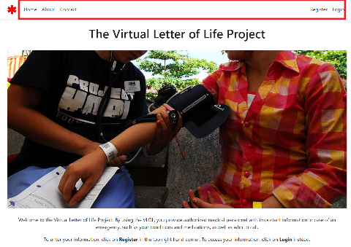

Figure 1: Home Page

## Contact Page

The Contact page provides contact information. Also, users have the option to contact the System Administrator about an issue by completing the form.

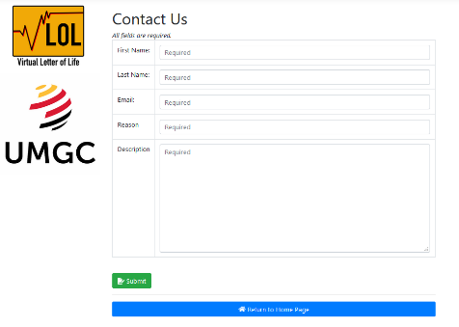

Figure 2: Contact Us

## About Page

The About page contains an introduction to the Virtual Letter of Life project. Also, users can view additional information about the Letter of Life and can obtain the LOL form using the “**Letter of Life**” hyperlink that is provided on this page.

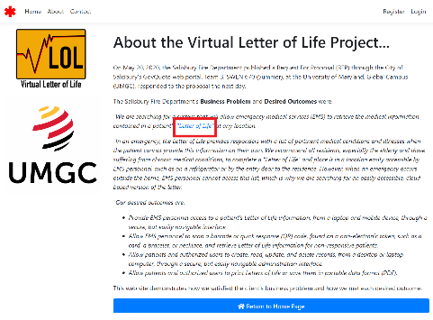

Figure 3: About

## New User Registration

New users can register and add their Letter of Life information by clicking “**Register**” (a) or “**Create Letter of Life Account”** (b) under **“Login”**:

1. Register using option (a) or (b)
2. Clicking on the “**Register**” options located on the top right-hand corner of the homepage.

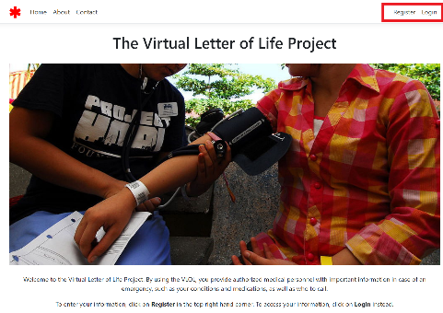

Figure 4: Registration Step 1(a)

1. Clicking the “**Create Letter of Life Account**” option located at the bottom of the Username/Password under “**Login**”.

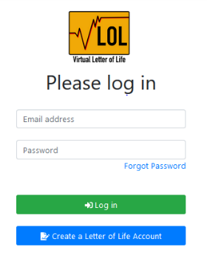

Figure 5:Registration Step 1(b)

1. Enter all required information and click on the **“Register”** button located at the bottom.

* All required field has a placeholder “required” in the textbox and user will not be able to proceed without filling out all required fields.
* The screenshot in Figure 7 shows a snippet of the required fields.

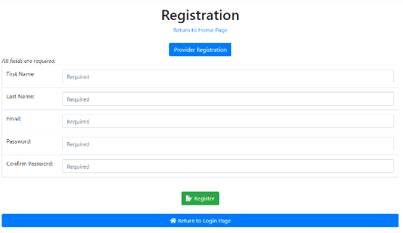

Figure 6:Registration Step 2

## New Provider Registration

New providers can register and **Register** on the home page.

1. Click the **Register** button

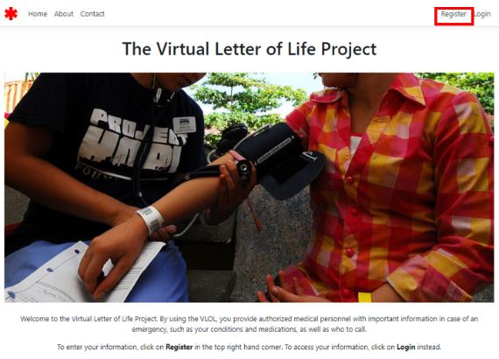

Figure 7: New Provider Registration

1. On the Registration page, select the **Provider Registration**

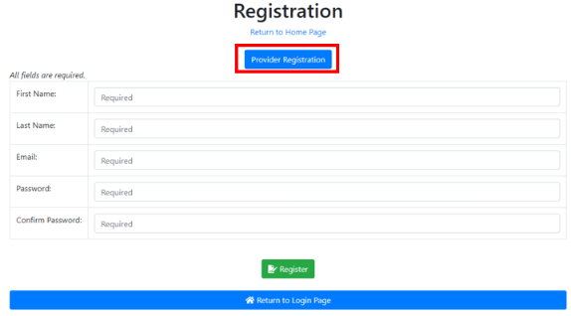

Figure 8: Provider Registration Button

1. Enter all required information and click on the **“Register”** button located at the bottom.

* All required field has a placeholder “required” in the textbox and user will not be able to proceed without filling out all required fields.

Screenshot in Figure 9 shows a snippet of the required fields

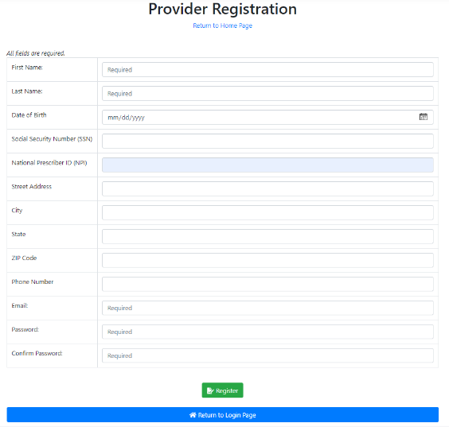

Figure 9: Provider Registration Page

## VLOL Log in/ Logout

Users who have previously registered on the VLOL application, follow the steps below to login into and log out of the application:

### **3.6.1. Login:**

1. Select the “**Login”** option located on the right-hand side of the home page.

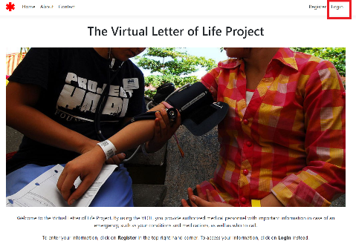

Figure 10:Login Step 1

1. Enter the Email address and Password and click on the **“Login”** button.

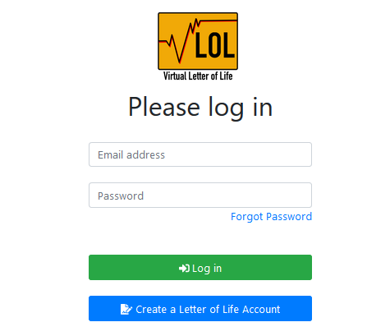

Figure 11:Login Step 2

### **3.6.2. Logout:**

Click on the “**Logout**” button located on the top right-hand side. The User will be logged out and redirected back to the Homepage.

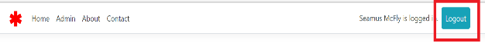

Figure 12:Logout

# Program Participant Guide

This section provides guidance to the Program Participants.

* The User must first register to the VLOL application as a participant (section 3.4).
* The Program Participants can only Edit their Profile, which will be the only option displayed in the Administration Menu.

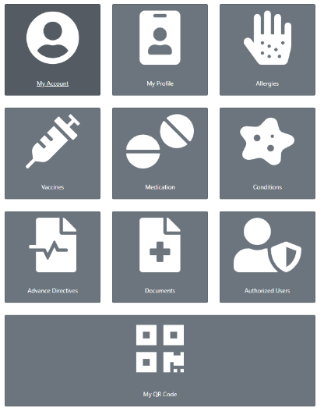

Figure 13:Program Participant Administration Menu

## Edit/ View My Account

1. Select the “**My Account”** option.

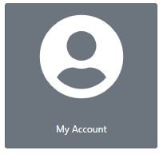

Figure 14: My Account

1. Modify the information and click on the “**Update**” button.

* Screenshot in Figure 15 shows a snippet of the fields

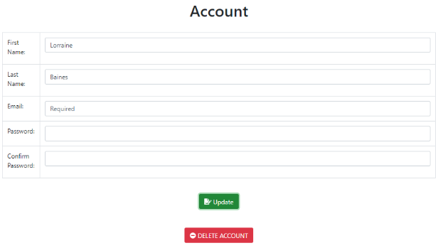

Figure 15: Edit Program Participant Account Step 2

## Edit/View Profile:

1. Select the “**My Profile**” option.

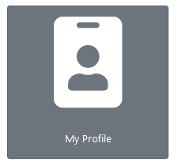

Figure 16:Edit Program Participant Profile Step 1

1. Modify the information and click on the “**Save**” button.

* Screenshot in Figure 17 shows a snippet of the fields

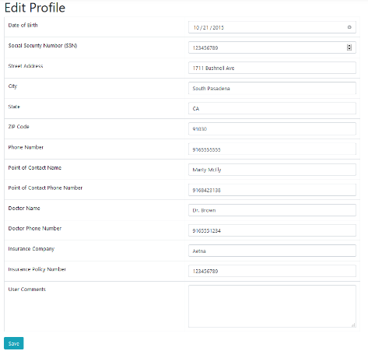

Figure 17:Edit Program Participant Profile Step 2

## Edit/View Allergies

1. Select the “**Allergies**” option

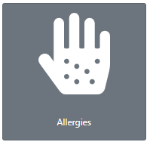

Figure 18:Edit/View Program Participant Allergies

1. View saved allergies

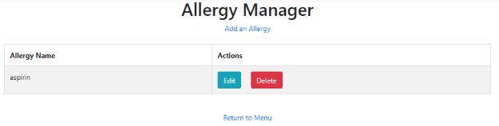

Figure 19: Program Participant Saved Allergies

1. To edit or Delete an allergy select the Action from the table

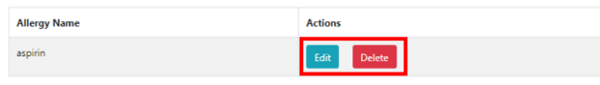

Figure 20: Program Participant Edit or Delete Allergy

1. To add an allergy, click “**Add an Allergy**”

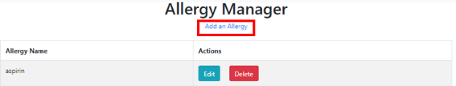

Figure 21: Program Participant Add an Allergy

1. Enter the name of the allergy and click “**Save**”

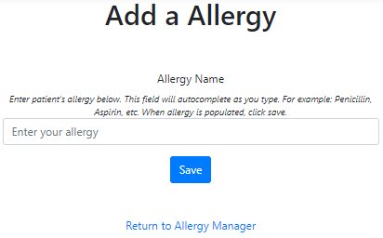

Figure 22: Program Participant Add Allergy Name

## Edit/View Vaccines

1. Select the “**Vaccines**” option



Figure 23:Edit/View Program Participant Vaccines

1. View saved vaccines

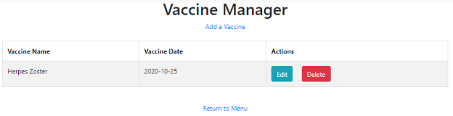

Figure 24: Program Participant Saved Vaccines

1. To edit or Delete a vaccine select the Action from the table

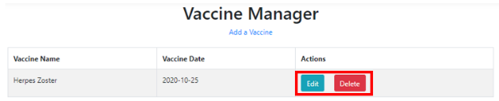

Figure 25: Program Participant Edit or Delete Vaccine

1. To add a vaccine, click “**Add a Vaccine**”

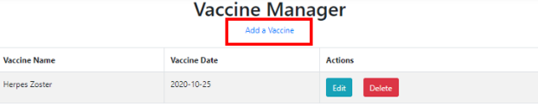

Figure 26: Program Participant Add a Vaccine

1. Enter the name of vaccine, date received and click “**Save**”

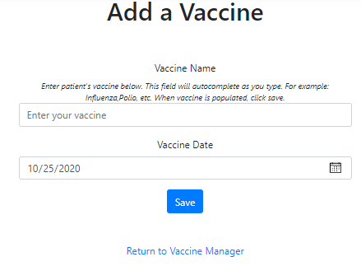

Figure 27: Add Vaccine Name and Date

## Edit/View Medication

1. Select the “**Medication**” option

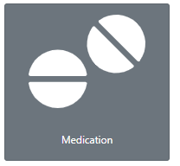

Figure 28:Edit/View Program Participant Medications

1. View saved Medications

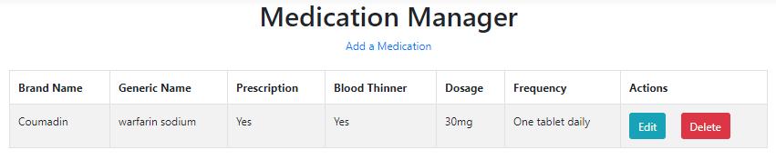

Figure 29:Edit/View Program Participant Medication

1. To edit or Delete a vaccine select the Action from the table

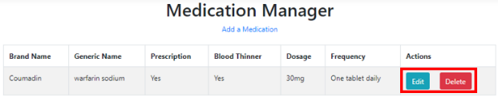

Figure 30: Program Participant Edit/Delete Medication

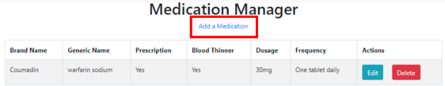

Figure 31: Program Participant Add a Medication

-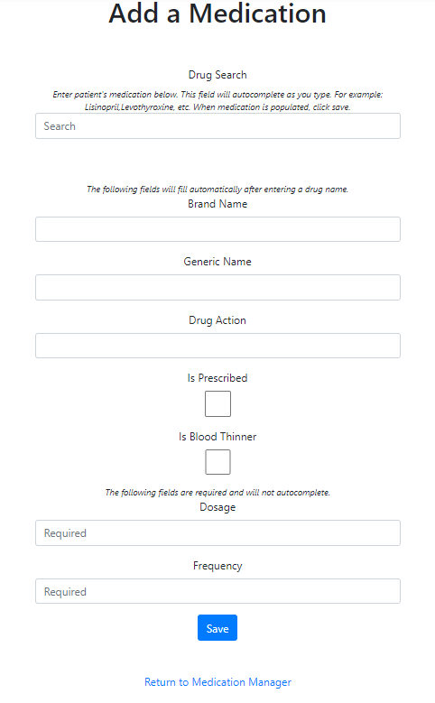

Figure 32: Program Participant Add Medication Details

## Edit/View Conditions

1. Select the “**Conditions**” option

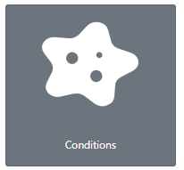

Figure 33: Edit/View Program Participant Conditions

1. View saved conditions

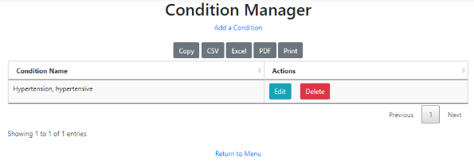

Figure 34: Program Participant Saved Conditions

1. To edit or Delete a condition select the Action from the table

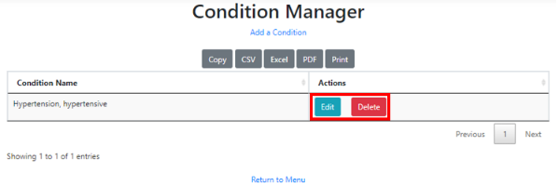

Figure 35: Program Participant Edit or Delete Condition

1. To add a vaccine, click “**Add a Condition**”

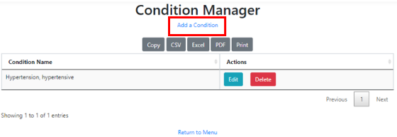

Figure 36: Program Participant Add a Condition

1. Enter the name of the condition and click “**Save**”

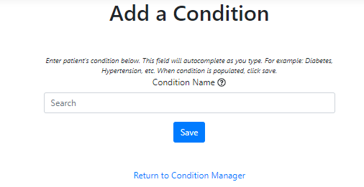

Figure 37: Program Participant Add Condition Name

## Edit/View Advance Directives

1. Select the “**Advance Directives**” option

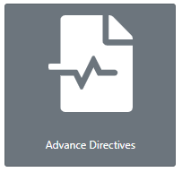

Figure 38:Edit/View Program Participant Advance Directives

1. View saved Advance Directives

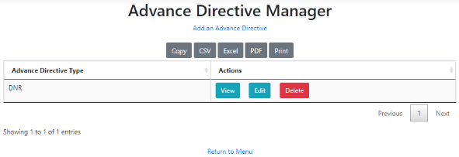

Figure 39: Program Participant Saved Advance Directives

1. To view, edit, or delete an Advance Directive select the Action from the table

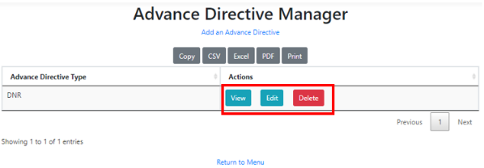

Figure 40: Program Participant View, Edit, or Delete Advance Directive

1. To add a vaccine, click “**Add an Advance Directive**”

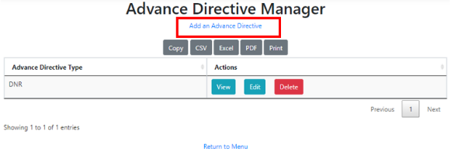

Figure 41: Program Participant Add an Advance Directive

1. Enter the name of Advance Directive, upload file, and click “**Save**”

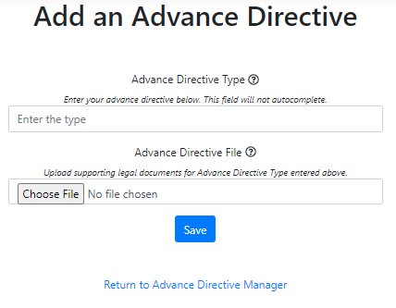

Figure 42: Program Participant Add Advance Directive and File

## Edit/View Documents

1. Select the “**Documents**” option

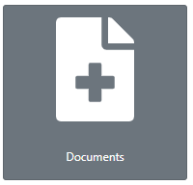

Figure 43:Edit/View Program Participant Documents

1. View saved Documents

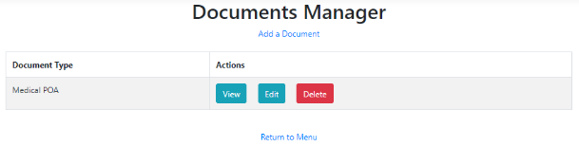

Figure 44: Program Participant Saved Documents

1. To view, edit, or delete a Document select the Action from the table

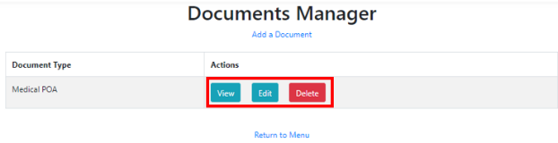

Figure 45: Program Participant View, Edit, or Delete Document

1. To add a vaccine, click “**Add an Advance Directive**”

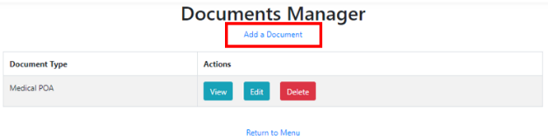

Figure 46: Program Participant Add a Document

1. Enter the name of the Document, upload file, and click “**Save**”

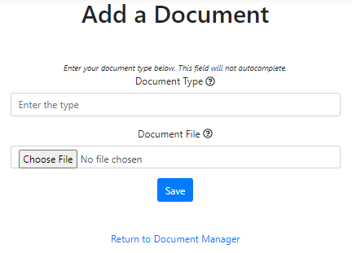

Figure 47: Program Participant Add Document and File

## Edit/View Authorized Users

1. Select the “**Authorized Users**” option.

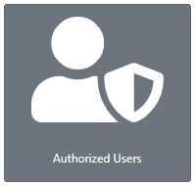

Figure 48:Edit/View Program Participant Authorized Users

1. View saved authorized users

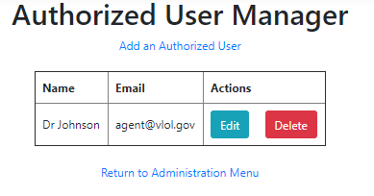

Figure 49: Program Participant Saved Authorized Users

1. To edit or Delete an authorized user selects the Action from the table

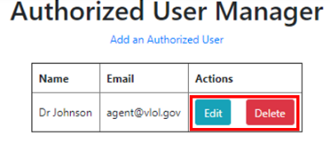

Figure 50: Program Participant Edit or Delete Authorized User

1. To add an authorized user, click “**Add an Authorized User**”

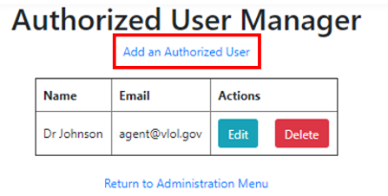

Figure 51: Program Participant Add Authorized User

1. Enter the name of an authorized user, email, and click “**Save**”

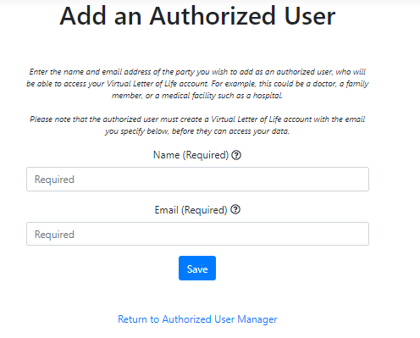

Figure 52: Program Participant Add Authorized Username and Email

## Regenerate/View QR Code

1. Select the “**My QR Code**” option



Figure 53: Program Participant Regenerate/View Program Participant QR Code

1. View QR Code

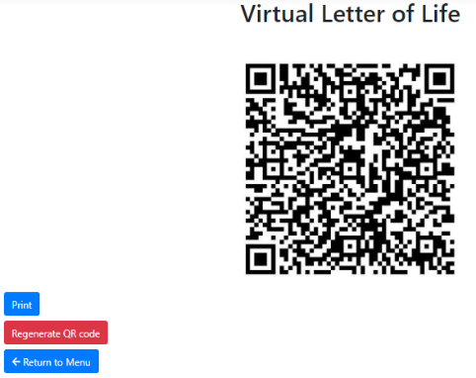

Figure 54: Program Participant QR Code

1. To Print or Regenerate QR Code select the option

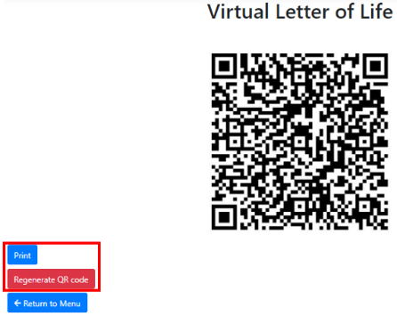

Figure 55: Program Participant Print or Regenerate QR Code

# Authorized User

This section provides guidance to Authorized Users.

* The User must first register to the VLOL application as a participant (section 3.4).
* The Authorized Users have all the functions of a Program Participant (section 4) as well as the ability to manage and edit users they are assigned to. 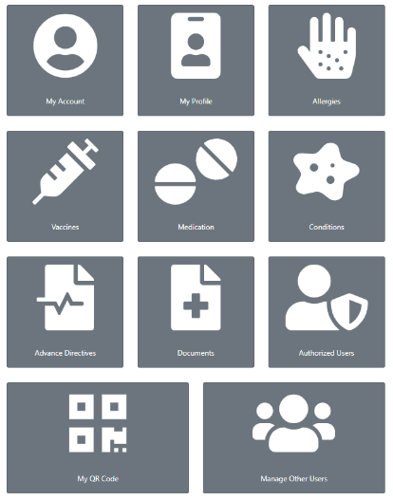

Figure 56: Authorized User Administrative Menu

## Manage Other Users

1. Select on the “**View**” option provided under Actions.

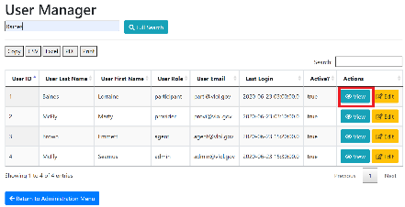

Figure 57: View Program Participant Step 1

1. User information is displayed.

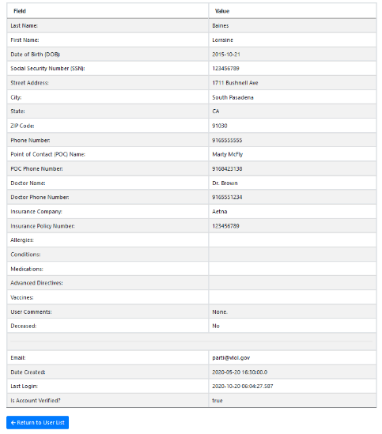

Figure 58: View Program Participant Step 2

### **5.1.1 Edit an existing Program Participant:**

1. Select a user to update and click on the “**Edit**” button.

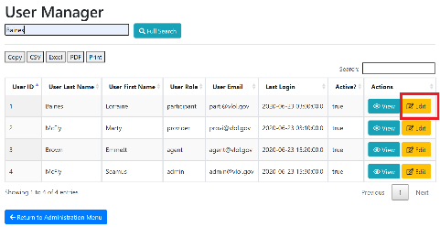

Figure 59:Edit Program Participant Step 1

1. Modify user information and click on the “**Save**” button located at the bottom of the page.

### **Filter a Program Participant:**

Enter Participant Name in the search bar located on the top right-hand side of the page. The system automatically filters out the matching result.

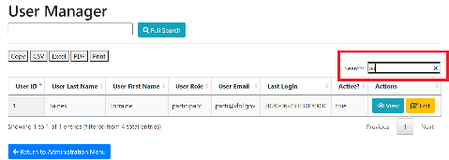

Figure 60: Filter Program Participant

# Provider Guide

This section provides guidance for the Providers

* User must first register to the VLOL application as a provider (section 3.5)
* The Provider can only Edit their Profile and assigned Program Participant’s profile.
* Upon login, the Provider will be able to see the authorized Administration menu option

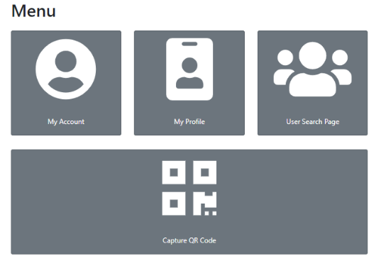

Figure 61:Provider Administration Menu

From the Administration Menu page, Providers have the option to view/edit their profile, manage an assigned Participants’ profile and capture QR Code. The section below (5.1 through 5.3 ) shows step by step instruction on how to navigate through each functionality.

## Edit/View Account:

1. Select the “**My Account”** option.



Figure 62: My Account

1. Modify the information and click on the “**Update**” button.

* Screenshot in Figure 58 shows a snippet of the fields



Figure 63: Edit Provider Account

## Edit/View Profile:

1. Select the “**My Profile**” option.



Figure 64:Edit Provider

1. Modify the information and click on the “**Save**” button.

* Screenshot in Figure 60 shows a snippet of the fields

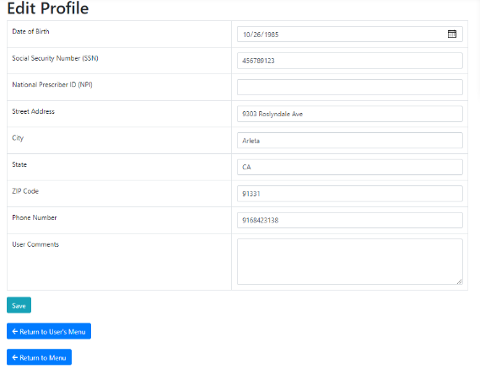

Figure 65:Edit Provider Account

## User Search Page:

1. Click on the “**User Search Page**” link provided under Administration Menu.

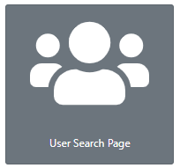

Figure 66:User Search Page

1. The user Manager page displays a list of assigned users. Participants Advocates can click on the “**Next**” or “**Previous**” buttons at the bottom of the list to move from one page to another.

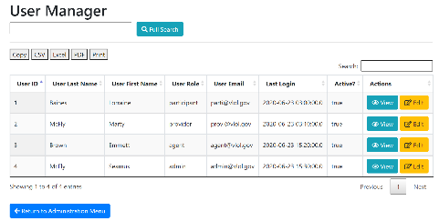

Figure 67:User Management Page Step 2

The following subsections 5.2.1 – 5.2.5 presents the functionalities under the User Manager page:

### **6.3.1. Export File**

To export a list of users to a different file format, click on one of the following buttons:

* **Copy**-copy the information to paste on to a clipboard.
* **CSV**-plain text format.
* **Excel**- excel spreadsheet format.
* **PDF**-portable data format.
* **Print**- printout information.

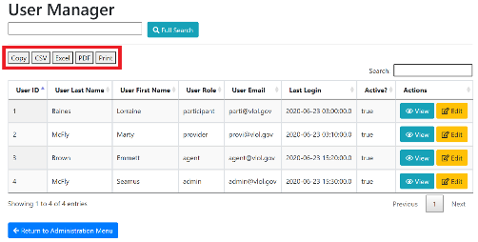

Figure 68:Export File

### **Search for an existing Program Participant:**

1. Enter User Last Name or First Name and click on the “**Full Search**” button.

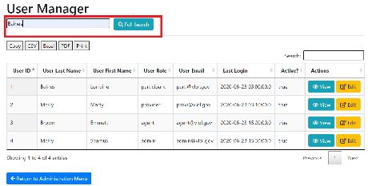

Figure 69:Search Program Participant Step 1

1. The search result is displayed.

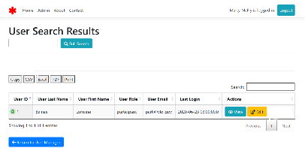

Figure 70:Search Program Participant Step 2

### **View an existing Program Participant:**

1. Select on the “**View**” option provided under Actions.



Figure 71:View Program Participant Step 1

1. User information is displayed.

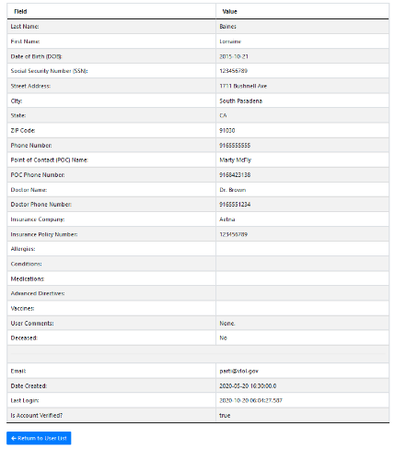

Figure 72:View Program Participant Step 2

### **6.3.4 Edit an existing Program Participant:**

1. Select a user to update and click on the “**Edit**” button.



Figure 73:Edit Program Participant Step 1

1. Modify user information and click on the “**Save**” button located at the bottom of the page.

### **Filter a Program Participant:**

Enter Participant Name in the search bar located on the top right-hand side of the page. The system automatically filters out the matching result.



Figure 74:Filter Program Participant

## Capture QR Code

1. To access the QR Code scanner, click on the “**Capture QR Code**” link provided under Administration Menu.

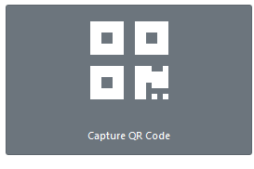

Figure 75:Capture QR Code Step 1

1. The user is directed to the QR Code Scanner page; click on the “**Request Camera Permissions**” button to allow access to the camera.

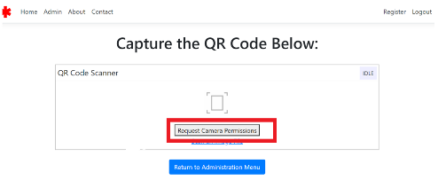

Figure 76:Capture QR Code Step 2

1. A screen will pop up with a request to access the camera. Click on the “**Allow**” button to allow camera access.

**Note:** this step is a one-time request that will occur if the device camera setting is off.

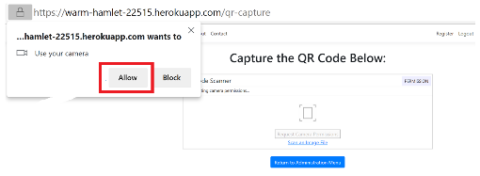

Figure 77:Capture QR Code Step 3

1. Click on the “**Start Scanning**” button to scan a QR code and hold till the four corners of the screen turns green.

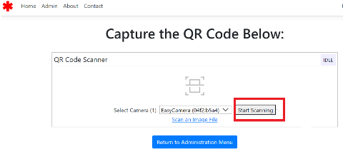

Figure 78:Capture QR Code Step 4

**Note:** If having difficulties scanning QR Code check the following:

* **Are you too close to or too far away from the QR Code?**  Try moving the QR Code closer or further away from the scanner.
* **Is the QR Code blurry?** Make sure the QR Code appears clearly on the scanner screen.

1. Participant’s information will be displayed.

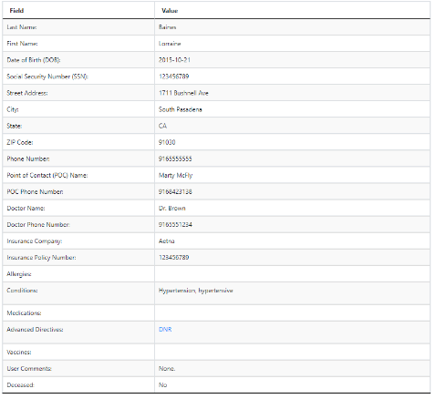

Figure 79:Capture QR Code Step 5

# System Admins Guide

This section provides guidance for the System Admins.

* User must first register to the VLOL application as a participant (section 3.4)
* After the user registers, the system admin must assign the user the role of System Admins.
* Upon login, the System Admins will be able to see the authorized Administration menu option (Figure 31)

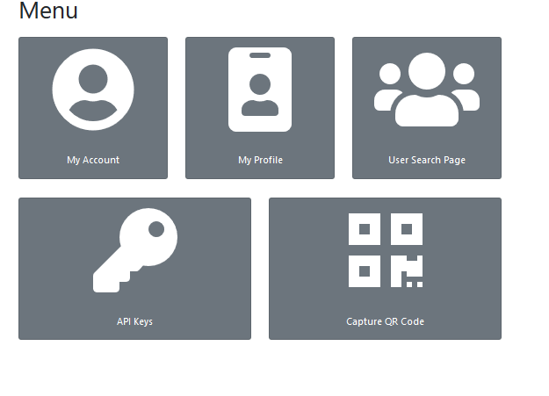

Figure 80:System Admin Administration Menu

From the Administration Menu page, System Admins have the option to edit their profile, access and manage, Users, API Keys, and Capture QR Code.

The section below (6.1 through 6.6 ) shows step by step instruction on how to navigate through each functionality.

## User Manager

1. To access and manage users, click on the “**User Management Page**” link provided under Administration Menu.

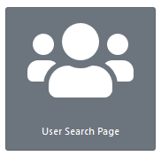

Figure 81:User Manager Page

1. User Manager page gets displayed with a list of existing users. Users can click on the “**Next**” or “**Previous**” buttons found at the bottom of the list to move from one page to another.

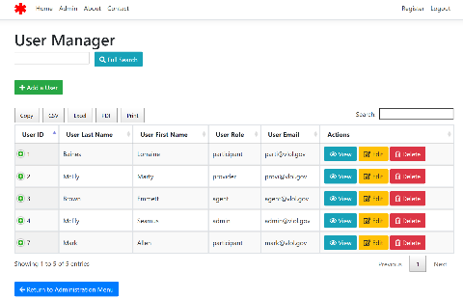

Figure 82:User Manager Menu

The following subsections of section 6.6 present the functionalities under the User Manager page:

### **Add a new User:**

1. Click on the “**Add User**” button.

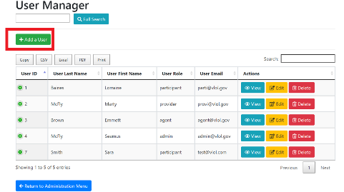

Figure 83:Add User Step 1

1. Enter all required role information and click on the **“Save”** button, the new condition gets added to the list.

* Screenshot in Figure 35 shows a snippet of the required fields

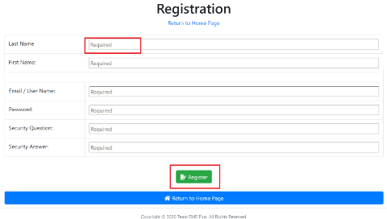

Figure 84:Add User Step 1

### **7.1.2 Export File**

To export a list of users to a different file format, click on one of the following buttons:

* **Copy**-copy the information to paste on to a clipboard.
* **CSV**-plain text format.
* **Excel**- excel spreadsheet format.
* **PDF**-portable data format.
* **Print**- printout information.

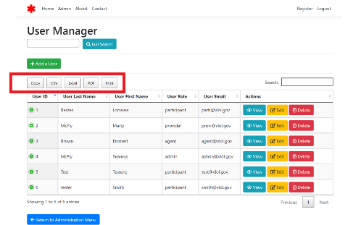

Figure 85:Export Roles

### **Search for an existing User:**

1. Enter User Last Name or First Name and click on the “**Full Search**” button.

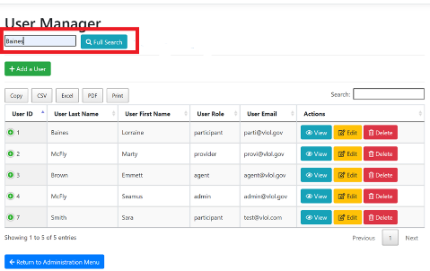

Figure 86:Search User Step 1

1. The search result is displayed.

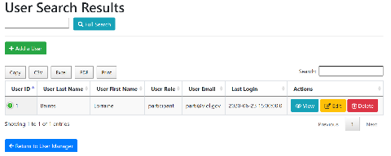

Figure 87:Search User Step 2

### **View an existing User:**

1. Select on the “**View**” option provided under Actions.

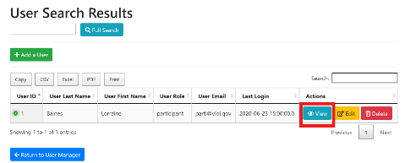

Figure 88:View User Step 1

1. User information is displayed.

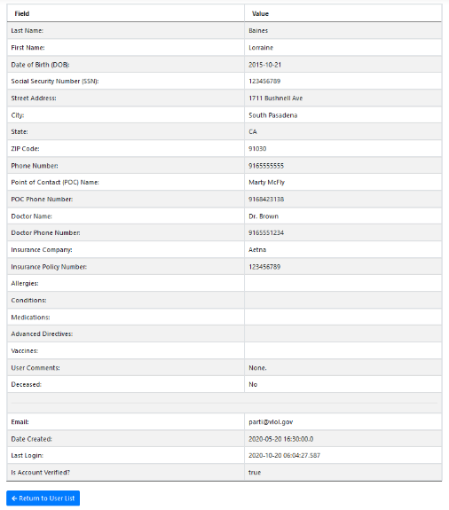

Figure 89:View User Step 2

### **7.1.5 Edit an existing User:**

1. Select the User and click on the “**Edit**” button.

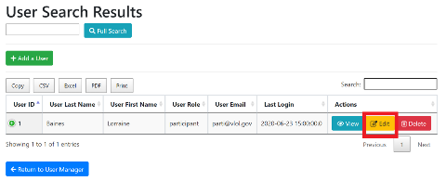

Figure 90:Edit User Step 1

1. Modify user information and click on the “**Save**” button located at the bottom of the page, all changes get saved.

* Screenshot in Figure 42 shows a snippet of the required fields

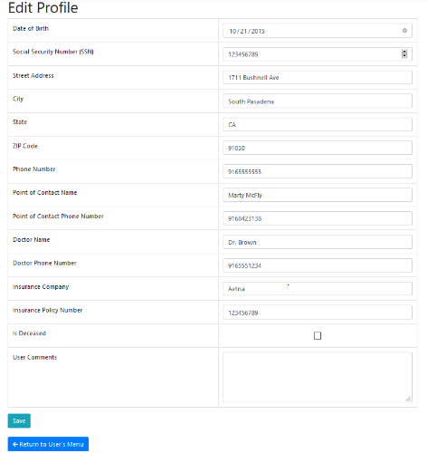

Figure 91:Edit User Step 2

### **7.1.6. Delete an existing User:**

Select the **“Delete”** option, and the user gets removed from the list.

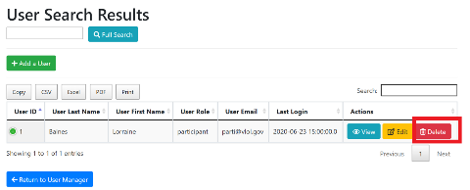

Figure 92:Delete User

### **7.1.7. Filter a User:**

Enter Medication Name in the search bar located on the right-hand side of the page. The system automatically filters out the matching result.

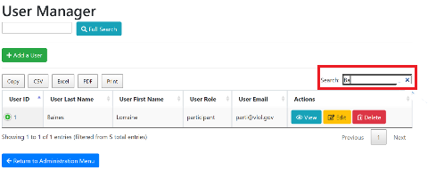

Figure 93:Filter User

## API Key Code

1. To access the API Keys, click on the “**API Keys**” link provided under Administration Menu.

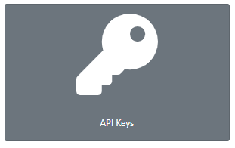

Figure 94: API Keys

1. View saved API Keys

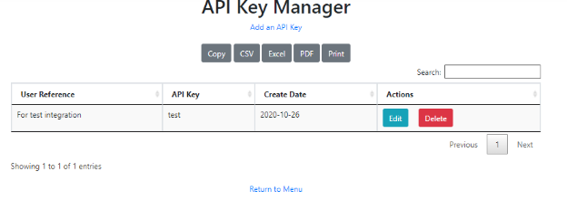

Figure 95: View Saved API Keys

1. To edit or delete an API Key click on the action from the table

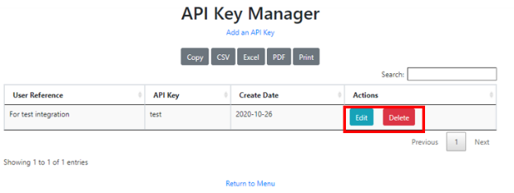

Figure 96: Edit or Delete API Key

1. To add a new API Key, click on “**Add an API Key**”

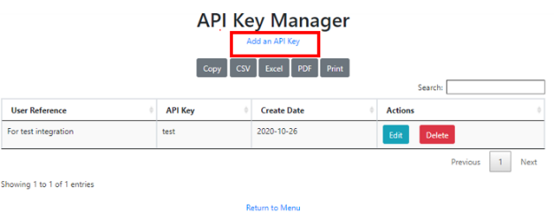

Figure 97: Add New API Key

1. Enter API Key and click “**Save**”

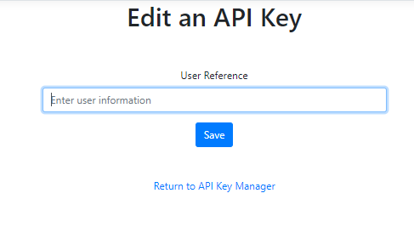

Figure 98: Enter new API Key

## Capture QR Code

1. To access the QR Code scanner, click on the “**Capture QR Code**” link provided under Administration Menu.

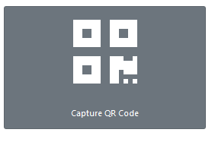

Figure 99:Capture QR Code Step 1

1. The user is directed to the QR Code Scanner page; click on the “**Request Camera Permissions**” button to allow access to the camera.



Figure 100:Capture QR Code Step 2

1. A screen will pop up with a request for camera access. Click on the “**Allow**” button to allow camera access.

**Note:** this step is a one-time request that will occur if the device camera setting is off.

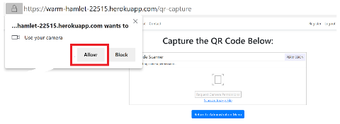

Figure 101:Capture QR Code Step 3

1. Click on the “**Start Scanning**” button to scan a QR code and hold till the four corners of the screen turns green.



Figure 102:Capture QR Code Step 4

**Note:** If having difficulties scanning QR Code check the following:

* **Are you too close to or too far away from the QR Code?**  Try moving the QR Code closer or further away from the scanner.
* **Is the QR Code blurry?** Make sure the QR Code appears clearly on the scanner screen.

1. Participant’s information will be displayed.

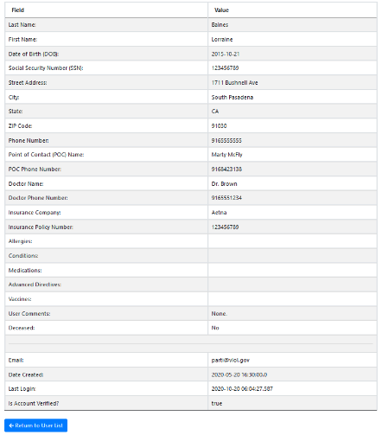

Figure 103:Capture QR Code Step 5

# Support

* For EMS personnel, Program Participants, and Patient Agent please go to the contact us page and contact the system admin.
* For System admins please refer to the RunBook.